FIVE TIPS TO IMPROVE YOUR CRITICAL THINKING
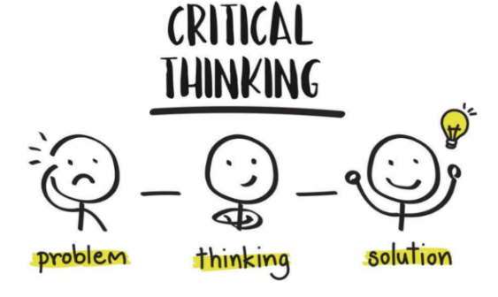Critical Thinking
“The objective analysis and evaluation of an issue in order to form a judgement.”
Every day a sea of decisions stretches before our PMs and it is impossible to make a perfect choice every time. However, there are a number of ways to improve your chances, one in particular is the technique of Critical Thinking.
This is the first of a series of articles that provide you with opportunities to learn more about this topic. This short TED Ed video takes you through a 5 step process to help you improve your critical thinking and support you to make better decisions. Why not take a look?
The 5-Step Process Includes:
- Formulate your question
- Gather your information
- Apply the information
- Consider the implications
- Explore other points of view

